Tugas mingguan ke-12
Nama : Silfiana Dwi Nabiilah
NIM : 221344028
Kelas : 2A TNK
Mata Kuliah : Elektronika Digital Lanjutan
Dosen : Bapak Ferry Satria, BSEE., M.T.
Ibu Rahmawati Hasanah. S.ST., M.T.

- Rangkaian Pendeteksi Urutan Input (Sequence Detector)
Contoh : Rancang dan rangkailah rangkaian pendeteksi urutan input dengan urutan : 1101
- State Diagram Mealy (OL)
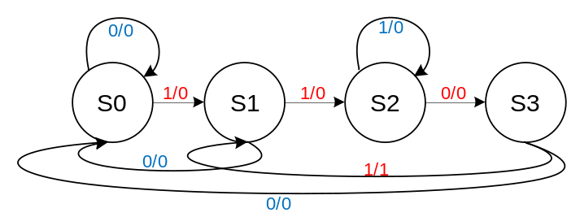
- State Table Mealy OL
PS | Ns, Z
PS | X = 0 | X = 1
S0 | S0, 0 | S1, 0
S1 | S0, 0 | S2, 0
S2 | S3, 0 | S2, 0
S3 | S0, 0 | S1, 1
- State Assignment Table :
PS | Ns, Z
PS | X = 0 | X = 1
00 | 00, 0 | 01, 0
01 | 00, 0 | 11, 0
11 | 10, 0 | 11, 0
10 | 00, 0 | 01, 1

- Persamaan K-maps
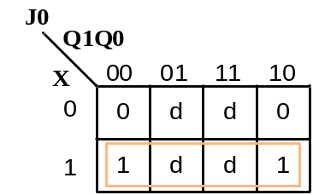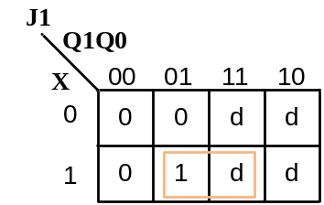
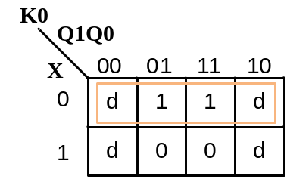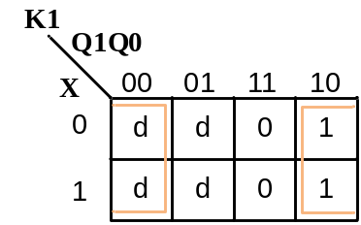
- Persamaan
J0 : X
J1 : X$Q0$
K0 :$\overline{X}$
K1 : $\overline{Q0}$
- Rangkaian
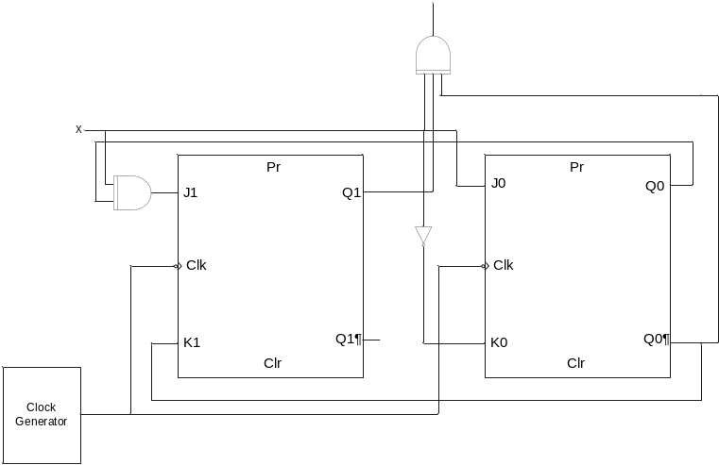
- State Diagram Mealy (NOL)
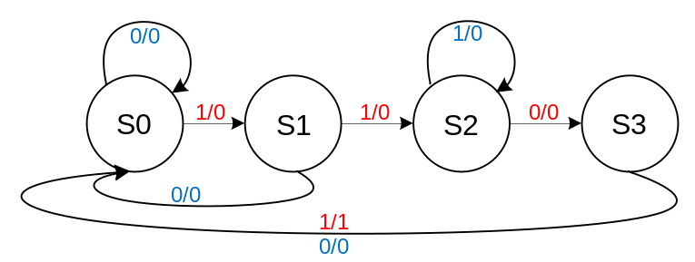
- State Table Mealy OL
PS | Ns, Z
PS | X = 0 | X = 1
S0 | S0, 0 | S1, 0
S1 | S0, 0 | S2, 0
S2 | S3, 0 | S2, 0
S3 | S0, 0 | S0, 1
- State Assignment Table :
PS | Ns, Z
PS | X = 0 | X = 1
00 | 00, 0 | 01, 0
01 | 00, 0 | 11, 0
11 | 10, 0 | 11, 0
10 | 00, 0 | 00, 1
- Persamaan K-maps
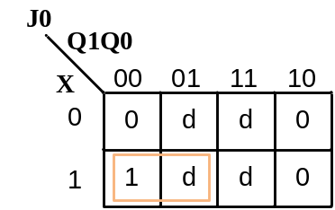
- Persamaan
J0 : X $\overline{Q0}$
J1 : X$Q0$
K0 :$\overline{X}$
K1 : $\overline{Q0}$

- Rangkaian
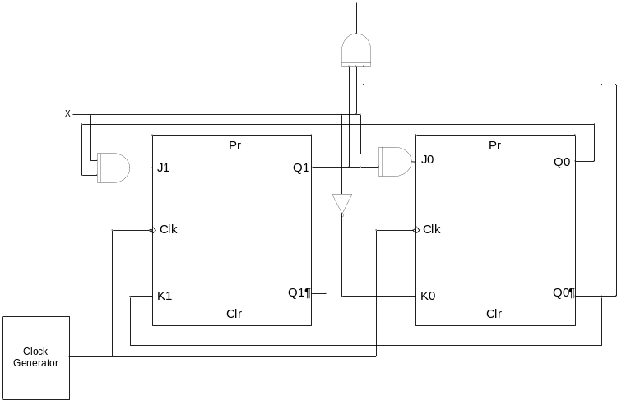
- Penjumlahan Rangkaian Sekuensial
Contoh : Rancang dan rangkailah seial adder menggunakan D-FF
- Menggunakan cara Mealy
- Diagram State
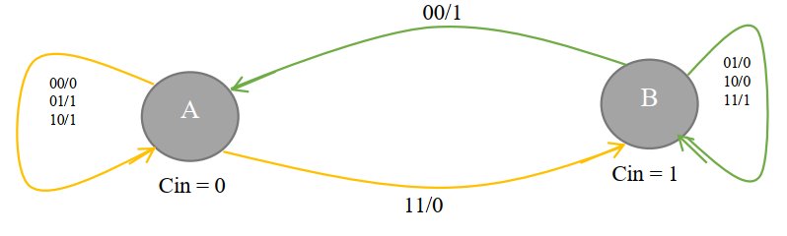
Tabel kabenaran Full Adder
A | B | Ci | Co | S
0 | 0 | 0 | 0 | 0
0 | 0 | 1 | 0 | 1
0 | 1 | 0 | 0 | 1
0 | 1 | 1 | 1 | 0
1 | 0 | 0 | 0 | 1
1 | 0 | 1 | 1 | 0
1 | 1 | 0 | 1 | 0
1 | 1 | 1 | 1 | 1
- State Table
State Assignment : A = 0; B = 1
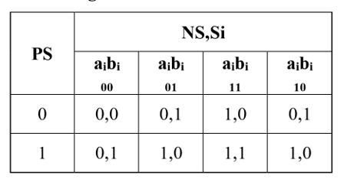

- Persamaan output
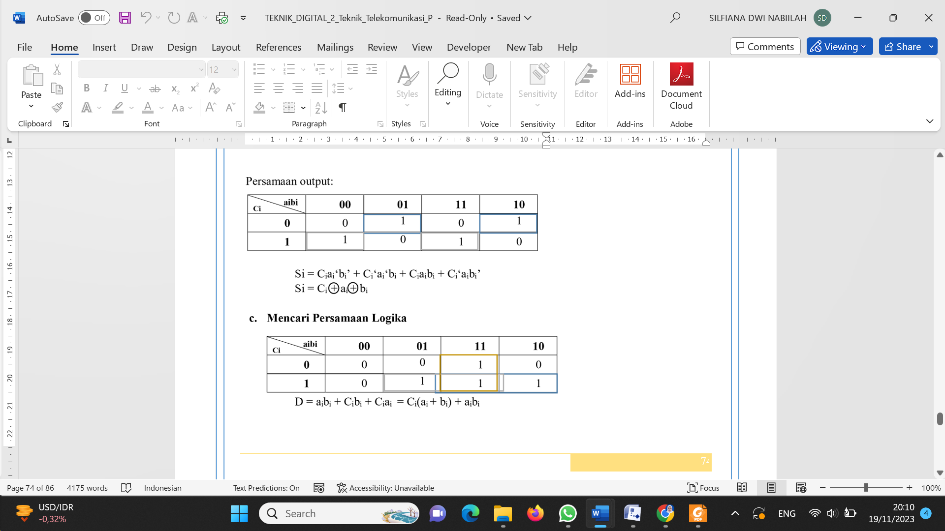
- Persamaan input
- Rangkaian
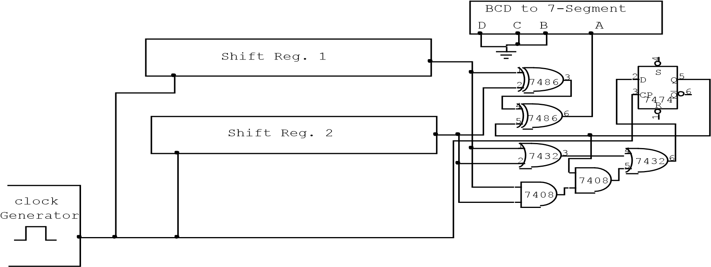
- Menggunakan cara Moore
- Diagram State
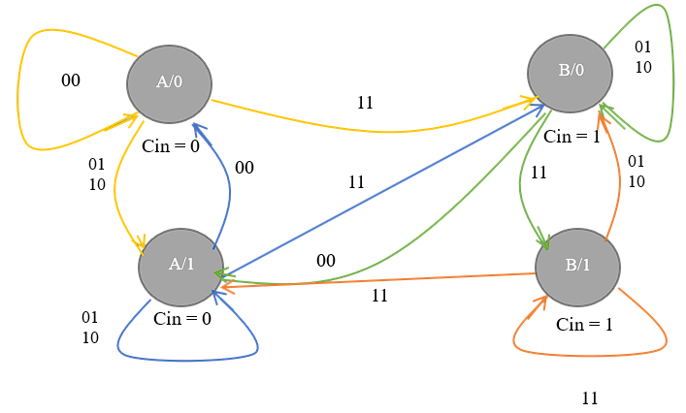
- State Table
PS |  | NS,Si |  |  | Output  Si
PS | aibi  00 | aibi  01 | aibi  11 | aibi  10 | Output  Si
00 | 00 | 11 | 01 | 11 | 0
01 | 11 | 01 | 10 | 01 | 0
11 | 00 | 11 | 01 | 11 | 1
10 | 11 | 01 | 10 | 01 | 1
State Assignment: A=00 ; B=01 ; C=11 ; D=10 State
- Persamaan Output
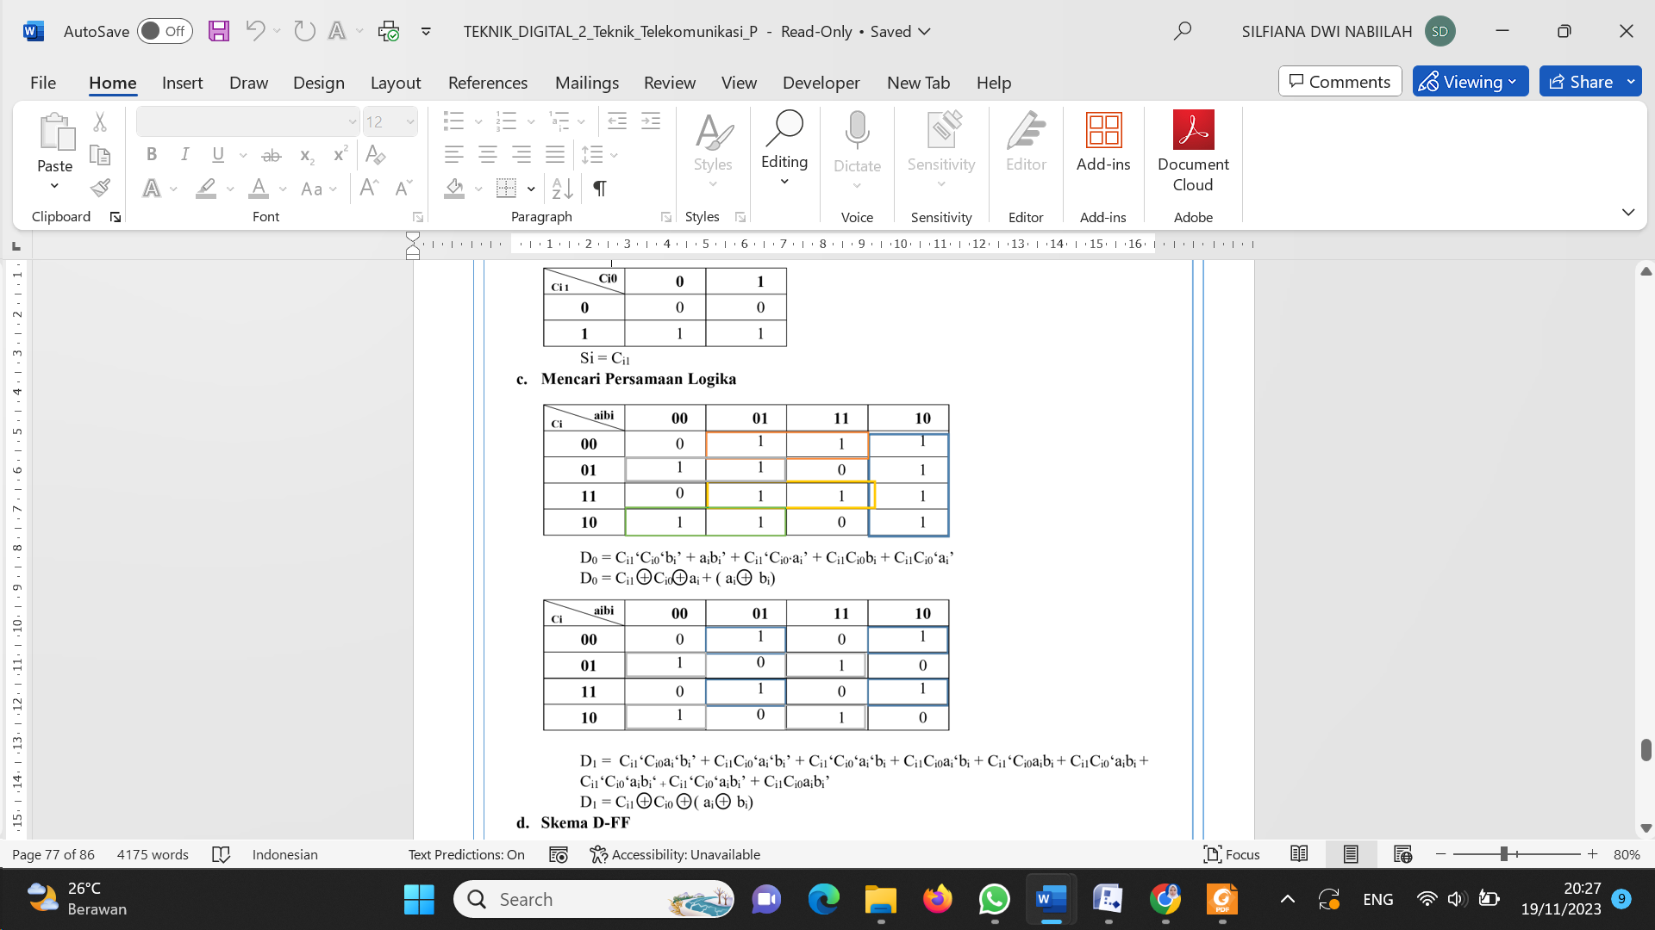
- Persamaan Input
- Rangkaian
